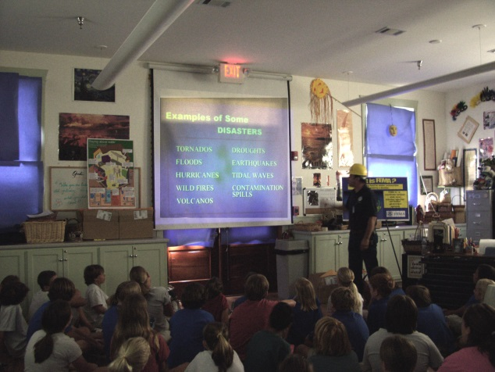
Are You Prepared?

In Lesson 3 of Unit 4, you learned about what to do before, during, and after an earthquake. You will use this knowledge to create an informational poster for a community in an area prone to earthquakes. Your poster should inform the people in the community about how to prepare in case of an earthquake.

First, you will need to research and find a city in the United States that is prone to earthquakes. You may choose any area in the United States that is in danger of earthquakes. The following link will help you find earthquake-prone areas in any of the 50 states.
US Earthquake Information by State/Territory

After you have chosen your city, you will need to do some further research on that area and on earthquake preparedness. You can use the linked websites from the above USGS site and others that you find helpful. Remember to use credible sources.

Requirements of Poster:

- You will be creating your poster using Word, Publisher, or PowerPoint.
  - If you need a refresher on making a PowerPoint presentation, click here.
- No matter which program you use to create your poster, you must keep your poster to one full page. Your poster may not be multiple pages.
- Your poster must state the location you chose (city and state).
- Your poster must include past earthquake information for that specific area, including magnitude and rate of occurrence in the area.
- You must give at least two courses of action that the community and families can take to prepare themselves for an earthquake before an earthquake occurs.
- You must provide at least two courses of action the community and families can take after an earthquake occurs to maintain the safety and welfare of everyone involved.
- You must provide the name, phone number, and website of an agency in the area to contact for help after an earthquake.
- You must include at least two actual images and one piece of clip art on your poster.
- You must include a Works Cited page listing all the websites you used, including the specific USGS website pages you used linked from the page above. Remember that your images need to be cited as well. All citations should include hyperlinks (URL) for credit. For help creating a Works Cited list, visit the following page: Purdue Owl
  - NOTE: Wikipedia and blogs are not considered credible sources and will not be accepted for any part of this project.

This is your time to be creative! You will need to use text boxes, clip art, and real images on your poster, along with any other design elements that you feel makes your poster interesting and informative. If you use a colorful background or other design elements, choose ones that do not distract readers from your important information.
Remember that the main focus of your poster is to inform your readers
1) why they should prepare for an earthquake,
2) how to prepare for an earthquake, and
3) how to respond to an earthquake.

Directions for Submitting Your Applied Knowledge Assessment
For this Applied Knowledge Assessment, you will be submitting ONE document for credit. This document will be either a Word file, Publisher file, or PowerPoint file. Save your document with your name included in the file extension. For example:
Earth_Sceince_Part1_U4L3_aka_poster_JohnSmith
After you have saved your document, submit it to be graded for your U4L3 Applied Knowledge Assessment.

